Date

27.03.2024

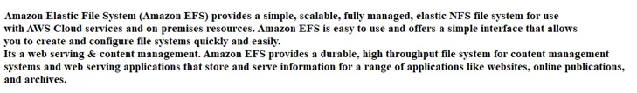

Now Create the all 3 instances in the same region

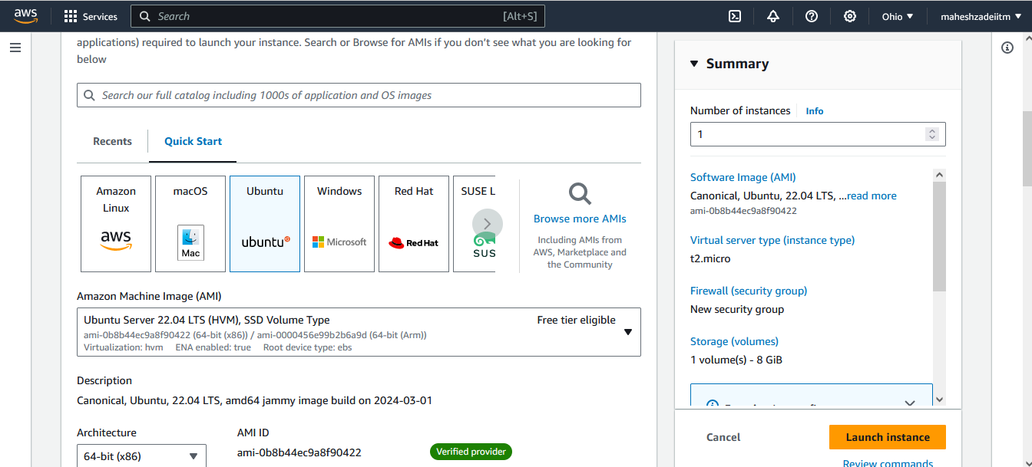

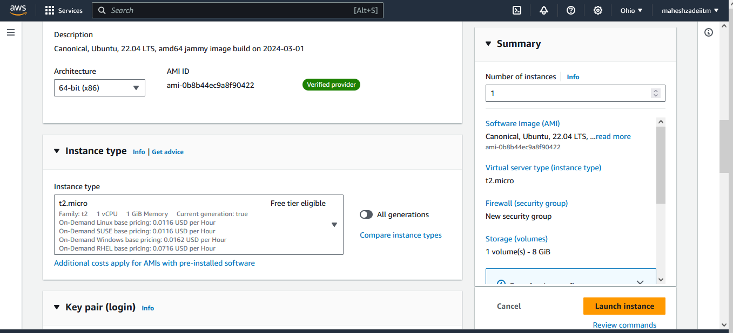

Launch Insatnce ,

In this way launch Redhat Linux and Amazon Linux 2 EC2 Instances

All 3 EC2 Instances create and able to SSH

Pls refer the below screen shots .

Now Go to EFS Service

We need to install the NFS common as medium for connection between EC2 Instances and EFS .

Pls Check Mount Targets are available OR Not in EFS

Also Check the Availbility Zone and Security groups

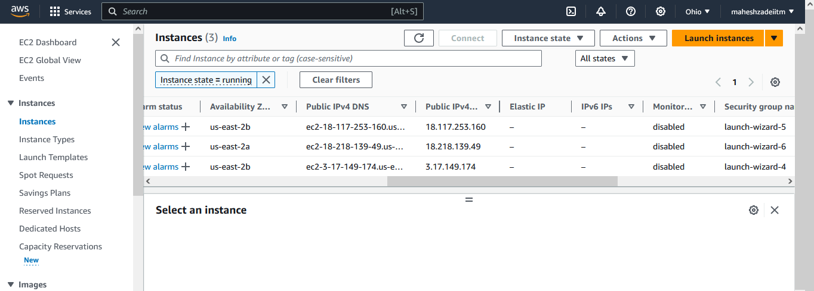

Again Go to EFS

Go to network in EFS and click on Mange

Remove Exosting Security group

And add the Ubuntu EC2 Machin Security Group

Click on Save

Now Login to EC2 Ubuntu Machine

Update the machine by below command

Now Type the below command to install nfs comman

Now create the NFS directory in ubuntu EC2 Instacne

For Mounting the we need to create the directory of the efs

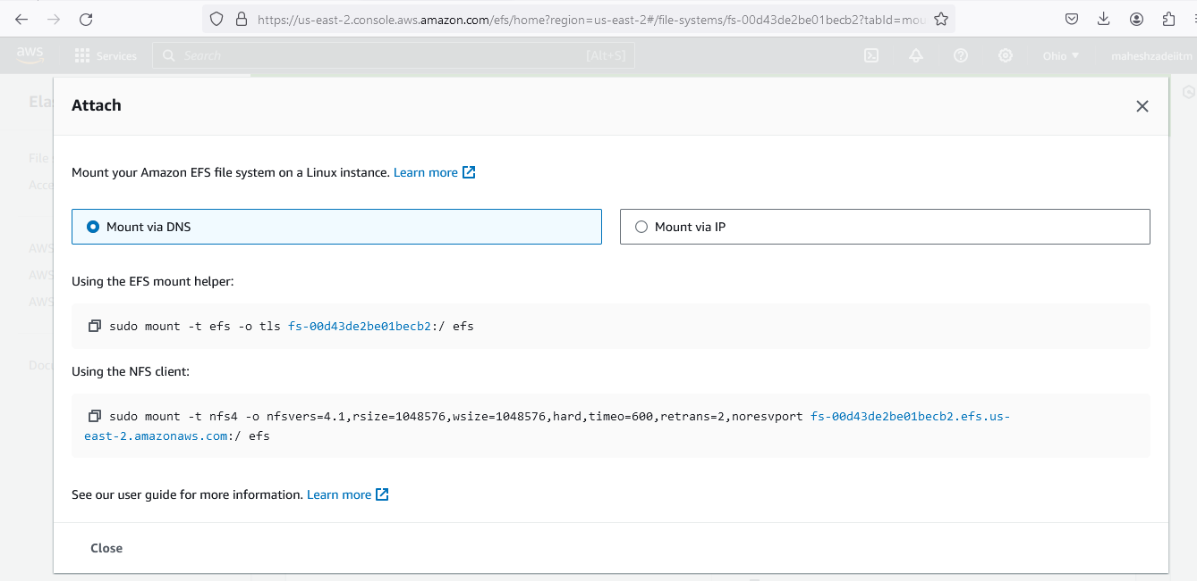

Check the directory Type ls command



No go back to nfs and copy the url to mount the efs

Copy nfs client code

sudo mount -t nfs4 -o nfsvers=4.1,rsize=1048576,wsize=1048576,hard,timeo=600,retrans=2,noresvport fs-00d43de2be01becb2.efs.us-east-2.amazonaws.com:/ efs

command is not working at the end

Can you pls help us on this?

Thanks